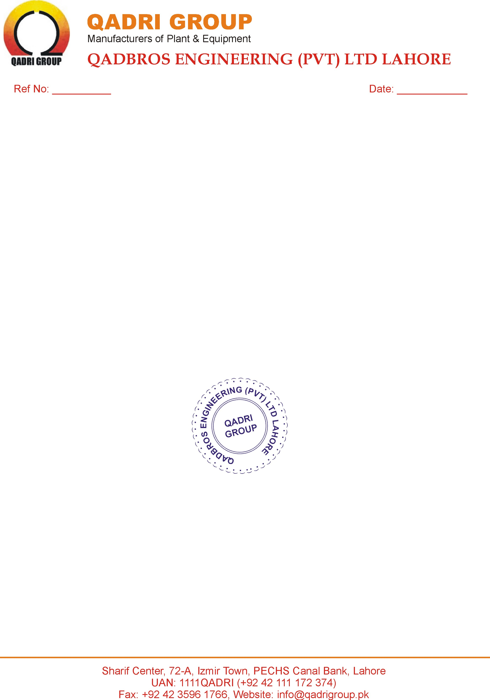

1140-18 <To2>

***EXPERIENCE CERTIFICATE***

*This is to certify that <Name> S/o <fname> has worked in our organization as a <Designation> from <From2> to <To2>.*

*During the job we always found him well disciplined and dutiful. He has rich experience in his job. He is honest and trust worthy gentleman. We wish him every success for his future betterment.*



**General Manager**